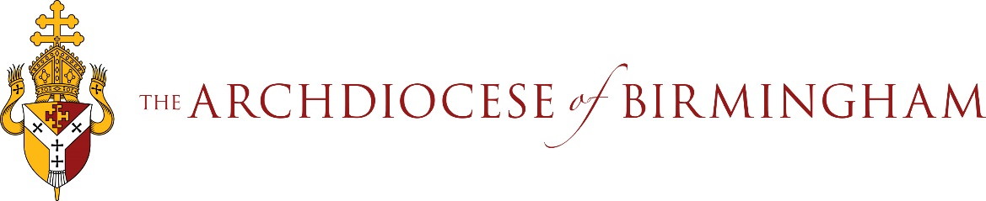

Guidelines for school reception staff taking calls / email enquiries from the media.
Be aware of who in school is the designated person for responding to media enquiries.

Email Enquiry
In the event of a media request being received to a generic school email address with an automatic reply, please ensure that the email is forwarded to the designated person as soon as possible.
Where there is no automatic reply, ensure that the email is forwarded to the designated person and an acknowledgement email is sent to confirm that the request has been received and has been passed to the relevant person for action.

Telephone Enquiry
DO
Take the person’s:
- name
- contact number
- organisation/media outlet they represent
- query (in brief)
- and the deadline they are working to.
DO NOT
- Put the phone down
- Say ‘no comment’ in response to media enquiries
- Assume that you need to answer the query because you took the call
- Disclose any information that you may have.

A possible response once you have requested the caller’s details:
I will pass your enquiry onto the appropriate person in school and will ask them to respond back to you direct.

If you are asked to answer the query yourself:
I’m not in a position to answer [QUESTION] and wouldn’t want to give you inaccurate information. Please may I take your contact details so the relevant person can get back to you.

If the caller is insistent or pushy, please provide the contact email address / telephone number for the Diocesan Communications Team:
communications@rcaob.org.uk
0121 230 6286
The Diocesan Communications Team will not take over responsibility for the matter but will engage with the media in support of your position.

March 2023

